Space News Update – May 2015
By Pat Williams
IN THIS EDITION:
- First ever flyby of Pluto – search for hazards.
- Traffic around Mars gets busy.
- International Space Station – Dragon returns research to Earth.
- What happens to an astronaut’s brain during a mission to Mars? Nothing good.
- Satellites make a load of difference to bridge safety.
- 60 countries each invested $10 million dollars or more in space applications.
- Links to other space and astronomy news published in May 2015.
Disclaimer - I claim no authorship for the printed material; except where noted.
THIS EDITION AND ALL FUTURE EDITIONS WILL BE IN WORD FORMAT TO ENABLE READERS TO CUT AND PASTE ITEMS OF PERSONAL INTEREST.
FIRST EVER FLYBY OF PLUTO – SEARCH FOR HAZARDS
The New Horizons probe will make the first-ever flyby of Pluto on July 14 2015, cruising within 7,800 miles (12,500 kilometers) of the frigid world's surface. NASA’s New Horizons team has analysed the first set of hazard-search images of the Pluto system taken by the approaching spacecraft itself – and so far, all looks clear for the spacecraft’s safe passage.

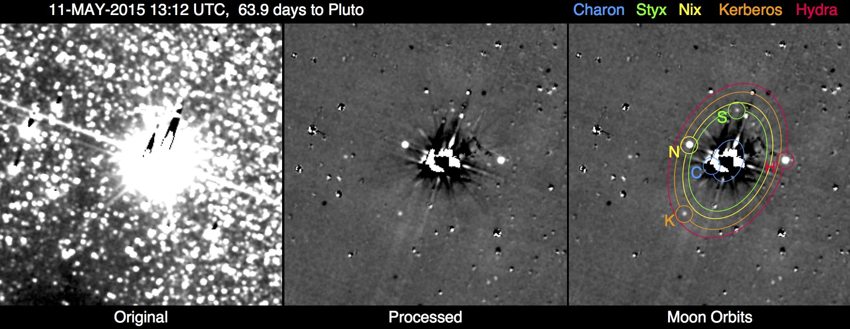
This image shows the results of the New Horizons team’s first search for potentially hazardous material around Pluto, conducted May 11-12, 2015, from a range of 47 million miles (76 million kilometers). The image combines 48 10-second exposures, taken with the spacecraft’s Long Range Reconnaissance Imager (LORRI), to offer the most sensitive view yet of the Pluto system.
The left panel is a combination of the original images before any processing. The combined glare of Pluto and its large moon Charon in the center of the field, along with the thousands of background stars, overwhelm any faint moons or rings that might pose a threat to the New Horizons spacecraft.
The central panel is the same image after extensive processing to remove Pluto and Charon’s glare and most of the background stars, revealing Pluto’s four small moons — Styx, Nix, Kerberos and Hydra — as points of light. The right panel overlays the orbits and locations of all five moons, including Charon. Remaining unlabeled spots and blemishes in the processed image are imperfectly removed stars, including variable stars which appear as bright or dark dots. The faint grid pattern is an artifact of the image processing. Celestial north is up in these images.
New Horizons team completes first search for Pluto system hazards (28 May 2015)

TRAFFIC AROUND MARS GETS BUSY

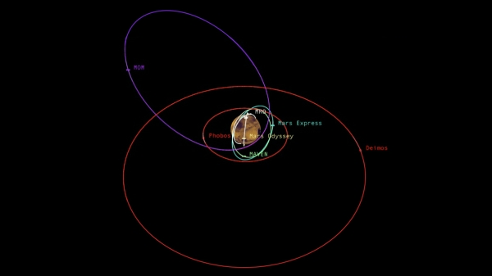
This graphic depicts the relative shapes and distances from Mars for five active orbiter missions plus the planet's two natural satellites. It illustrates the potential for intersections of the spacecraft orbits. (Courtesy: NASA/JPL-Caltech)

2014’s addition of two new spacecraft orbiting Mars brought the census of active Mars orbiters to five, the most ever. NASA's Mars Atmosphere and Volatile Evolution (MAVEN) Mars Orbiter Mission from India Mars Express from ESA (2003) Mars Odyssey from NASA (2001) Mars Reconnaissance Orbiter (MRO) from NASA (2006). The newly enhanced collision-avoidance process also tracks the approximate location of NASA's Mars Global Surveyor, a 1997 orbiter that is no longer working.

It's not just the total number that matters, but also the types of orbits missions use for achieving their science goals. MAVEN, which reached Mars on Sept. 21, 2014, studies the upper atmosphere. It flies an elongated orbit, sometimes farther from Mars than NASA's other orbiters and sometimes closer to Mars, so it crosses altitudes occupied by those orbiters. For safety, NASA also monitors positions of ESA's and India's orbiters, which both fly elongated orbits.
Traffic management at Mars is much less complex than in Earth orbit, where more than 1,000 active orbiters plus additional pieces of inactive hardware add to hazards. All five active Mars orbiters use the communication and tracking services of NASA's Deep Space Network, which is managed at JPL. A side benefit of it is that information about when two orbiters will be near each other -- though safely apart -- could be used for planning coordinated science observations. The pair could look at some part of Mars or its atmosphere from essentially the same point of view simultaneously with complementary instruments.
Odyssey, MRO and MAVEN -- together with NASA's two active Mars rovers, Opportunity and Spirit -- are part of NASA's robotic exploration of Mars that is preparing the way for human-crewed missions there in the 2030s and later, in NASA's Journey to Mars strategy. Traffic around Mars gets busy (4 May 2015)

INTERNATIONAL SPACE STATION – DRAGON RETURNS RESEARCH TO EARTH

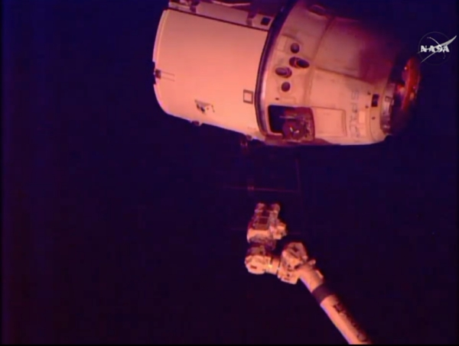
The SpaceX Dragon cargo spacecraft was released from the International Space Station's robotic arm at 7:04 a.m. EDT Thursday 21st May. The capsule then performed a series of departure burns and manoeuvers to move beyond the 656-foot (200-meter) "keep out sphere" around the station and begin its return trip to Earth. (Courtesy: NASA)

SpaceX's Dragon cargo spacecraft splashed down in the Pacific Ocean at 12:42 p.m. EDT Thursday with almost 3,100 pounds of NASA cargo from the International Space Station, including research on how spaceflight and microgravity affect the aging process and bone health.

Dragon is the only space station resupply spacecraft able to return a significant amount of cargo to Earth. It is the U.S. company’s sixth NASA-contracted commercial resupply mission to the station and carried more than two tons of supplies and scientific cargo when it lifted off from Cape Canaveral Air Force Station in Florida on April 14. NASA also has contracted with American companies SpaceX and Boeing to develop their Crew Dragon and CST-100, respectively, to once again transport astronauts to and from the orbiting laboratory from the United States in 2017.
The returning Space Aging study, for example, examines the effects of spaceflight on the aging of roundworms, widely used as a model for larger organisms. By growing millimetre-long roundworms on the space station, researchers can observe physiological changes that may affect the rate at which organisms age. This can be applied to changes observed in astronauts, as well, particularly in developing countermeasures before long-duration missions.
Spaceflight-induced health changes, such as decreases in muscle and bone mass, are a major challenge facing astronauts. "We investigate solutions on the station not only to keep astronauts healthy as the agency considers longer space exploration missions but also to help those on Earth who have limited activity as a result of aging or illness."
Also returned on Dragon were samples for the Osteocytes and Mechanomechano-transduction (Osteo-4) investigation. Researchers with Osteo-4 will observe the effects of microgravity on the function of osteocytes, the most common cells in bone. Understanding the effects of microgravity on osteocytes will be critical as astronauts plan for future missions that require longer exposure to microgravity, including the NASA’s journey to Mars. The results derived from this study also could have implications on Earth for patients suffering bone disorders related to disuse or immobilization, as well as metabolic diseases such as osteoporosis.
Equipment and data from the Special Purpose Inexpensive Satellite (SpinSat) investigation also made the trip back to Earth. The SpinSat study tested how a spherical satellite, measuring 22 inches in diameter, moves and positions itself in space using new thruster technology. Researchers can use high-resolution atmospheric data captured by SpinSat to determine the density of the thermosphere, one of the uppermost layers of the atmosphere. With better knowledge of the thermosphere, engineers and scientists can refine satellite and telecommunications technology. Critical NASA research returns to Earth aboard U.S. SpaceX Dragon spacecraft (21 May 2015)

WHAT HAPPENS TO AN ASTRONAUT’S BRAIN DURING A MISSION TO MARS? NOTHING GOOD.
It’s besieged by destructive particles that can forever impair cognition, according to a UC Irvine radiation oncology study appearing in the May 1 edition of Science Advances. Charles Limoli and colleagues found that exposure to highly energetic charged particles – much like those found in the galactic cosmic rays that bombard astronauts during extended spaceflights – cause significant damage to the central nervous system, resulting in cognitive impairments.
“This is not positive news for astronauts deployed on a two- to three-year round trip to Mars,” said Limoli, a professor of radiation oncology in UCI’s School of Medicine. “Performance decrements, memory deficits, and loss of awareness and focus during spaceflight may affect mission-critical activities, and exposure to these particles may have long-term adverse consequences to cognition throughout life.”
For the study, rodents were subjected to charged particle irradiation (fully ionized oxygen and titanium) at the NASA Space Radiation Laboratory at the Brookhaven National Laboratory before being sent back to Limoli’s Irvine lab. The researchers found that exposure to these particles resulted in brain inflammation, which disrupted the transmission of signals among neurons. Imaging revealed how the brain’s communication network was impaired through reductions in the structure of nerve cells called dendrites and spines. Additional synaptic alterations in combination with the structural changes interfered with the capability of nerve cells to efficiently transmit electrochemical signals. Furthermore, these differences were parallel to decreased performance on behavioural tasks designed to test learning and memory.
Similar types of more severe cognitive dysfunction are common in brain cancer patients who have received various photon-based radiation treatments at much higher doses. In other research, Limoli studies the impact of chemotherapy and cranial irradiation on cognition.
While cognitive deficits in astronauts would take months to manifest, Limoli said, the time required for a mission to Mars is sufficient for such deficits to develop. People working for extended periods on the International Space Station do not face the same level of bombardment with galactic cosmic rays, as they are still within the protective magnetosphere of the Earth.
The irradiated particles that compose these galactic cosmic rays are mainly remnants of past supernova events.
Limoli’s work is part of NASA’s Human Research Program. Investigating how space radiation affects astronauts and learning ways to mitigate those effects are critical to further human exploration of space, and NASA needs to consider these risks as it plans for missions to Mars and beyond.
But what can be done to protect astronauts speeding off to the red planet?
As a partial solution, Limoli said, spacecraft could be designed to include areas of increased shielding, such as those used for rest and sleep. However, these highly energetic particles will traverse the ship nonetheless, he noted, “and there is really no escaping them.”
Preventative treatments offer some hope. “We are working on pharmacologic strategies involving compounds that scavenge free radicals and protect neurotransmission,” Limoli said. “But these remain to be optimized and are under development.” Long-term galactic cosmic ray exposure leads to dementia-like cognitive impairments
(1 May 2015)

SATELLITES MAKE A LOAD OF DIFFERENCE TO BRIDGE SAFETY
Forth Road Bridge
When extreme weather comes our way, real-time information from space can help us to decide if closing a bridge is the right thing to do.

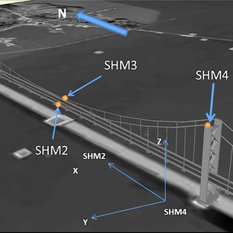 Satnav sensors and wind meters

ESA is working with the UK’s University of Nottingham to monitor the movements of large structures as they happen using satellite navigation sensors. The team fixed highly sensitive satnav receivers for detecting movements as small as 1 cm at key locations on the Forth Road Bridge in Scotland. After analysing Earth observation images of the Forth Road Bridge dating back seven years, the team found no displacements of the towers or the surrounding soil. The bridge can move significantly under high winds and moved 3.5 m laterally and 1.83 m vertically under a wind speed of 41 m/s. This information is extremely useful for understanding how much the bridge can move under extreme weather conditions. This allows us to decide to close the bridge based on precise deformation information.
Satellites make a load of difference to bridge safety (15 May 2015)

60 COUNTRIES EACH INVESTED $10 MILLION OR MORE IN SPACE APPLICATIONS

21 new emerging space nations to invest in industry projects over next decade
Paris, Washington D.C., Montreal, Yokohama, May 13, 2015 - According to Euroconsult's newly released research report, Profiles of Government Space Programs, world government expenditures for space programs decreased by 4% to $66.5 billion in 2014. The decrease in U.S. military space expenditures combined with the impact of adverse exchange rates on Russia had a considerable influence on global trends as the two countries together account for 65% of space expenditures worldwide. Government spending excluding the U.S. and Russia actually increased by 8% in 2014.
Tensions on public finances have pushed governments toward severe budget arbitrations with choices to be made over spending priorities. However, this situation did not stop governments from funding new large-scale programs, even in countries impacted by the economic slowdown. Ariane-6 in Europe, the expanded IGS reconnaissance program in Japan, or the Radarsat Constellation Mission in Canada are prominent examples of governments' commitment to acquire/maintain strategic assets while supporting domestic industrial capabilities. In many cases, governments' growing inclination to integrate space in a broader strategy to preserve national security and sovereignty has been a key motivation factor to sustain or even increase funding levels to strategic programs.
"In 2014, 60 countries invested $10 million or more in space applications and technologies; this is twice as many as in 2004," said Jean-Baptiste Thepaut, Senior Consultant at Euroconsult and editor of the report. "In addition, 21 more countries have been identified with plans for investment in space projects. Such dynamism demonstrates how space technologies and applications are seen by governments as a valuable investment to support their national social, economic, strategic, and technological development."
Highlights from the 80+ agencies and organizations profiled in the report include:
- • The U.S. invested $34.7 billion in its space program (civil and defence) in 2014, confirming the downward trend initiated since the start of the decade. Russia has initiated an ambitious plan to modernize and expand its space-based assets in all domains. It has accelerated its investments in the last five years at an average growth of 11% in local currency. However, penalized by decreasing oil prices, the Russian budget converted into dollars decreased by 11% in 2014 compared to that of 2013.
- • Another six countries invested over $1 billion in their space programs: Japan, China, France, Germany, Italy, and India, to which shall be added the European Union. It is notable that China now surpasses France as the fourth largest space program. 18 countries recorded over $100 million in spending; this includes countries with stable investments for over a decade such as the U.K., Canada, and South Korea, and countries undertaking the development of their first or second generation of space-based assets such as Kazakhstan, Mexico, and Brazil. Only 11 countries were part of this list in 2009.
- • 34 other countries invested between $10 million and $100 million in their national space programs; 22 of them were part of this list in 2009 and only 11 in 2004.
Government spending in space programs at $66.5 billion in 2014 (13 May 2015)

LINKS TO OTHER SPACE AND ASTRONOMY NEWS PUBLISHED IN MAY 2015
ASTEROIDS
Fresh evidence for how water reached Earth found in asteroid debris (7 May 2015) Water delivery via asteroids or comets is likely taking place in many other planetary systems, just as it happened on Earth, according to new research.
Asteroid research benefits from Gaia satellite mission (20 May 2015) Astronomical research on asteroids, i.e. minor planets, is also benefiting from the large-scale Gaia mission of the European Space Agency (ESA).
ASTROPHYSICS
A hot start to the origin of life? (5 May 2015) DNA is synonymous with life, but where did it originate? One way to answer this question is to try to recreate the conditions that formed DNA’s molecular precursors.
COMET

Comet Wild 2: A window into the birth of the solar system? (13 May 2015)
Our solar system, and other planetary systems, started as a disk of microscopic dust, gas and ice around the young Sun.

DWARF PLANETS

Ceres animation showcases bright spots (11 May 2015)
The mysterious bright spots on the dwarf planet Ceres are better resolved in a new sequence of images taken by NASA's Dawn spacecraft on May 3 and 4, 2015.

EARTH

Improved detection of radio waves from space (4 May 2015)
Geodesy is the scientific discipline that deals with the measurement of the Earth.

Breaking waves perturb Earth's magnetic field (11 May 2015)

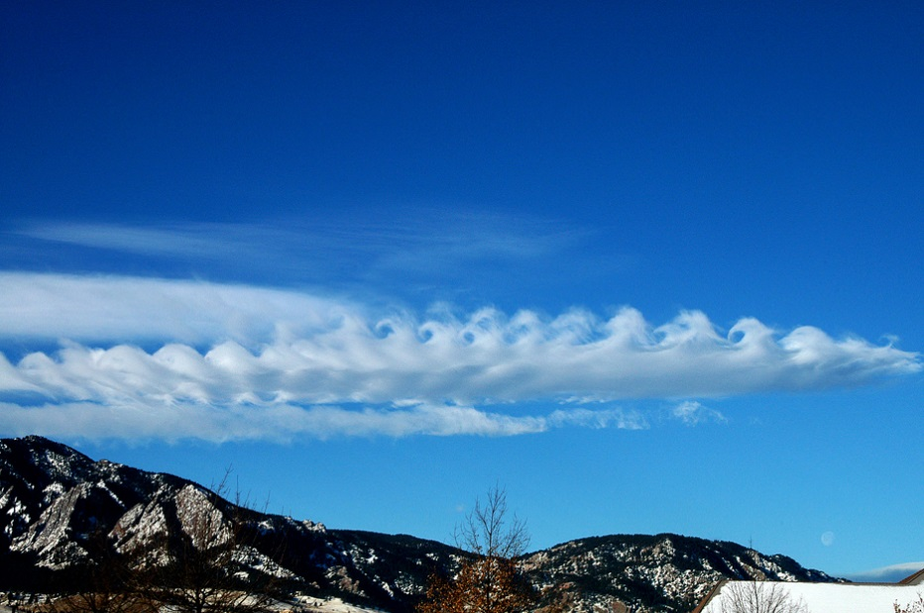
Kelvin-Helmholtz Clouds
The underlying physical process that creates striking "breaking wave" cloud patterns in our atmosphere also frequently opens the gates to high-energy solar wind plasma that perturbs Earth's magnetic field, or magnetosphere, which protects us from cosmic radiation.

Soil moisture mission begins science operations (19 May 2015)
NASA's new Soil Moisture Active Passive (SMAP) mission to map global soil moisture and detect whether soils are frozen or thawed has begun science operations.

EXOPLANETS

First evidence of changing conditions on a super Earth (5 May 2015)
For the first time, researchers led by the University of Cambridge have detected atmospheric variability on a rocky planet outside the solar system, and observed a nearly threefold change in temperature over a two year period.

Weather forecasts for alien worlds beyond our solar system (12 May 2015)
Using sensitive observations from the Kepler space telescope, an international team of astrophysicists from the University of Toronto, York University and Queen’s University Belfast have uncovered evidence of daily weather cycles on six extra-solar planets seen to exhibit different phases.

FUTURE MISSIONS AND RESEARCH

NASA selects advanced space technology concepts for further study (8 May 2015)
NASA has selected 15 proposals for study under Phase I of the NASA Innovative Advanced Concepts (NIAC), a program that aims to turn science fiction into science fact through the development of pioneering technologies.

Europa mission begins with selection of science instruments (26 May 2015)
NASA has selected nine science instruments for a mission to Jupiter’s moon Europa, to investigate whether the mysterious icy moon could harbour conditions suitable for life.

NASA begins testing Mars lander in preparation for next mission to red planet (27 May 2015) Testing is underway on NASA’s next mission on the journey to Mars, a stationary lander scheduled to launch in March 2016.

GALAXIES

A new galaxy distance record (5 May 2015)
An international team of astronomers, led by Yale University and University of California scientists, has pushed back the cosmic frontier of galaxy exploration to a time when the universe was only 5 percent of its present age of 13.8 billion years.

Cause of galactic death: strangulation (13 May 2015)
A new study, published today in the journal Nature, has found that the primary cause of galactic death is strangulation, which occurs after galaxies are cut off from the raw materials needed to make new stars.

Galaxy’s snacking habits revealed (19 May 2015)
A team of Australian and Spanish astronomers have caught a greedy galaxy gobbling on its neighbours and leaving crumbs of evidence about its dietary past.

Herschel's hunt for filaments in the Milky Way (28 May 2015)
Observations with ESA's Herschel space observatory have revealed that our Galaxy is threaded with filamentary structures on every length scale.

Giant halo around the Andromeda Galaxy (7 May 2015)
Scientists using NASA's Hubble Space Telescope have discovered that the immense halo of gas enveloping the Andromeda galaxy, our nearest massive galactic neighbour, is about six times larger and 1,000 times more massive than previously measured.

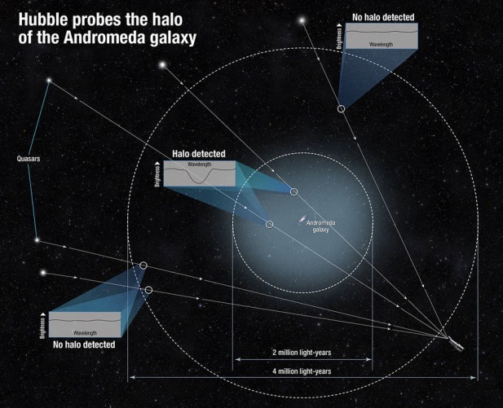
The immense halo of gas enveloping the Andromeda galaxy, our nearest massive galactic neighbor, is about six times larger and 1,000 times more massive than previously measured.
Credits: NASA/STScI

GAMMA-RAY BURST

Lawrence Livermore scientists move one step closer to mimicking gamma-ray bursts (26 May 2015)
Using ever more energetic lasers, Lawrence Livermore researchers have produced a record high number of electron-positron pairs, opening exciting opportunities to study extreme astrophysical processes, such as black holes and gamma-ray bursts.

JUPITER AND MOONS

Europa's mystery dark material could be sea salt (12 May 2015)
NASA laboratory experiments suggest the dark material coating some geological features of Jupiter's moon Europa is likely sea salt from a subsurface ocean, discoloured by exposure to radiation.

MARS

Mars rover's laser-zapping instrument gets sharper vision (22 May 2015)
Tests on Mars have confirmed success of a repair to the autonomous focusing capability of the Chemistry and Camera (ChemCam) instrument on NASA's Curiosity Mars rover.

Similarities between aurorae on Mars and Earth (27 May 2015)
An international team of researchers has for the first time predicted the occurrence of aurorae visible to the naked eye on a planet other than Earth.

MERCURY

MESSENGER reveals Mercury’s ancient magnetic field secrets (7 May 2015)
New data from MESSENGER, the spacecraft that orbited Mercury for four years before crashing into the planet a week ago, reveal that Mercury’s magnetic field is almost four billion years old.

MOON

LRO moves closer to the lunar surface (5 May 2015)
NASA’s Lunar Reconnaissance Orbiter (LRO) has completed a manoeuvre that lowered the spacecraft’s orbit to within 20 kilometers (12 miles) above areas near the lunar South Pole, the closest the spacecraft has ever been to the lunar surface.

PLUTO

New Horizons spots Pluto’s faintest known moons (12 May 2015)
For the first time, NASA's New Horizons spacecraft has photographed Kerberos and Styx – the smallest and faintest of Pluto's five known moons.

New Horizons sees more detail as it draws closer to Pluto (27 May 2015)
What a difference 20 million miles makes! Images of Pluto from NASA's New Horizons spacecraft are growing in scale as the spacecraft approaches its mysterious target.

SATURN AND MOONS

Saturn moon's activity could be 'curtain eruptions' (6 May 2015)
New research using data from NASA's Cassini mission suggests most of the eruptions from Saturn's moon Enceladus might be diffuse curtains rather than discrete jets.
Geochemical process on Saturn’s moon linked to life’s origin (6 May 2015)
New work from a team including Carnegie’s Christopher Glein has revealed the pH of water spewing from a geyser-like plume on Saturn’s moon Enceladus.

Cassini prepares for last up-close look at Hyperion (28 May 2015)
NASA's Cassini spacecraft will make its final close approach to Saturn's large, irregularly shaped moon Hyperion on Sunday, May 31.

SOLAR SYSTEM

Space debris from satellite explosion increases collision risk for space craft (6 May 2015) Debris from the US Defence Meteorological Satellite Program (DMSP) F13 satellite, which recently exploded in orbit, could pose a threat to other spacecraft and missions according to new research from the University of Southampton.

What the solar system looked like as a ‘toddler’ (27 May 2015)
Astronomers have discovered a disc of planetary debris surrounding a young sun-like star that shares remarkable similarities with the Kuiper Belt that lies beyond Neptune, and may aid in understanding how our solar system developed.

STARS AND STAR CLUSTERS

ALMA discovers proto super star cluster (7 May 2015)
Globular clusters – dazzling agglomerations of up to a million ancient stars – are among the oldest objects in the universe.

Dark side of star clusters (13 May 2015)
Observations with ESO’s Very Large Telescope in Chile have discovered a new class of “dark” globular star clusters around the giant galaxy Centaurus A.

Delta Cephei's hidden companion (12 May 2015)
Delta Cephei, prototype of Cepheids, which has given its name to all similar variable stars, was discovered 230 years ago by the English astronomer, John Goodricke.

Subaru Telescope observes superflare stars with large starspots (11 May 2015)
A team of astronomers has used the High Dispersion Spectrograph on the Subaru Telescope to conduct spectroscopic observations of Sun-like "superflare" stars first observed and catalogued by the Kepler Space Telescope.

Hubble catches a stellar exodus in action (14 May 2015)
Using NASA's Hubble Space Telescope, astronomers have captured for the first time snapshots of fledgling white dwarf stars beginning their slow-paced, 40-million-year migration from the crowded centre of an ancient star cluster to the less populated suburbs.

One-of-a-kind star nicknamed 'Nasty' (21 May 2015)
Astronomers using NASA's Hubble Space Telescope have uncovered surprising new clues about a hefty, rapidly aging star whose behaviour has never been seen before in our Milky Way galaxy.

Monitoring magnetospheres (25 May 2015)
Queen’s University PhD student Matt Shultz is researching magnetic, massive stars, and his research has uncovered questions concerning the behaviour of plasma within their magnetospheres.

Shining message about the end of the dark ages (28 May 2015)
An international team, including researchers from the Centre for Astronomy of Heidelberg University (ZAH), has discovered three “cosmic Methusalems” from the earliest years of the universe.

SUPERNOVA

Star explosion is lopsided (7 May 2015)
NASA's Nuclear Spectroscopic Telescope Array, or NuSTAR, has found evidence that a massive star exploded in a lopsided fashion, sending ejected material flying in one direction and the core of the star in the other.

Rare, early moments of baby supernovae (20 May 2015)
Astronomers are going gaga over newborn supernova measurements taken by NASA’s Kepler and Swift spacecraft, poring over them in hopes of better understanding what sparks these world-shattering stellar explosions.

Supernova hunting with supercomputers (19 May 2015)
Type Ia supernovae are famous for their consistency. Ironically, new observations suggest that their origins may not be uniform at all.

Supernovas help ‘clean’ galaxies (26 May 2015)
Supernovas just might be the cleaning service of the universe.

Caltech astronomers observe a supernova colliding with its companion star (20 May 2015) Type Ia supernovae, one of the most dazzling phenomena in the universe, are produced when small dense stars called white dwarfs explode with ferocious intensity.

SUN

Using a sounding rocket to help calibrate NASA's SDO (19 May 2015) Terminated 21 May 2015
Watching the sun is dangerous work for a telescope. Solar instruments in space naturally degrade over time, bombarded by a constant stream of solar particles that can cause a film of material to adhere to the optics.

TECHNOLOGY
UTEP to develop next generation rocket engines (29 May 2015)
The University of Texas at El Paso (UTEP) has been awarded a $5 million grant from NASA to develop the next generation of rocket engines using liquid methane.

Pat Williams. May 2015

